**Field PCA on Partial warps (18 landmarks, 32PWs)**

Past3: (x-axis) PC1- 23.127%, (y-axis) PC2- 15.043%

First graph[Biome]- Red (Amazon), Green (Cerrado), Blue (Mata Atlantica)

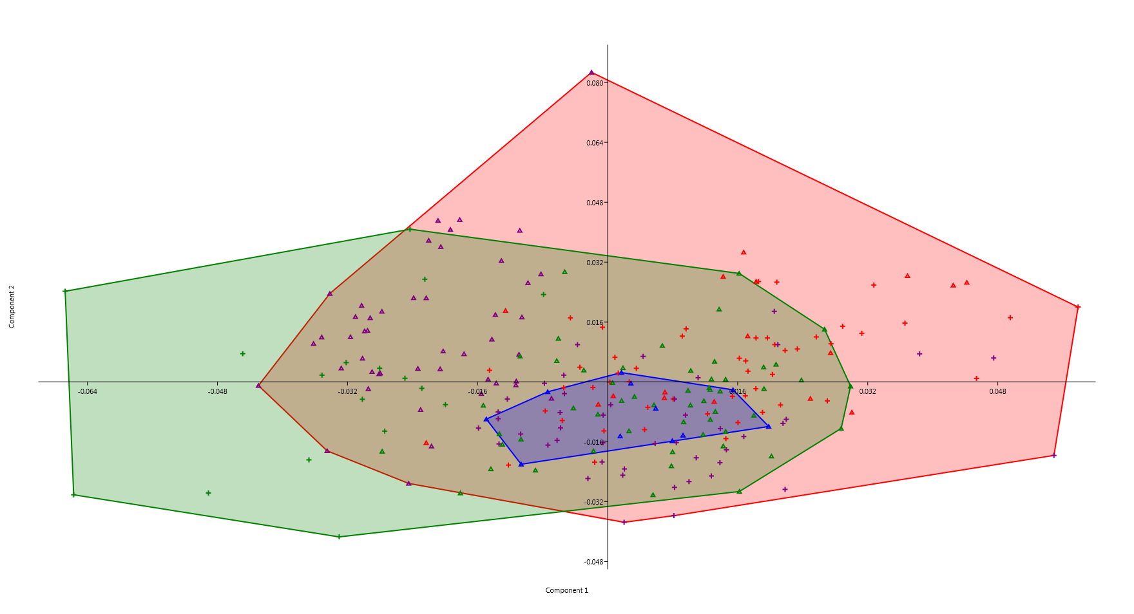

Second graph[State]- Red (Amazonas), Purple (Rondonia), Green (Tocantins), Blue (Rio de Janeiro)

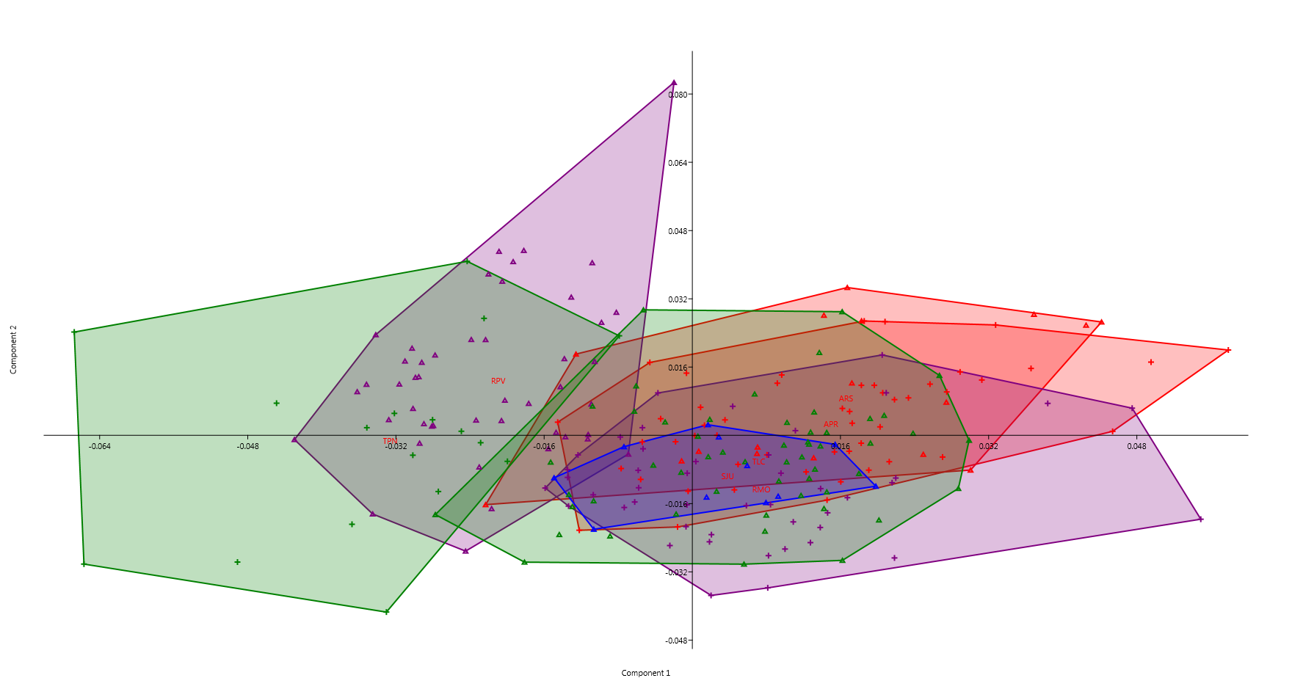

CLIC (COV): PC1-27.905%, PC2- 19.182%

First graph[Biome]- Red (Amazon), Green (Cerrado), Blue (Mata Atlantica)

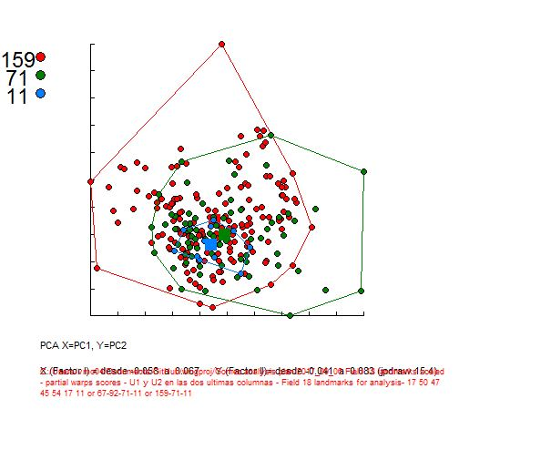

Second graph[State]- Reds (Amazonas), Purples (Rondonia), Greens (Tocantins), Blue (Rio de Janeiro)

